

SUMMER NEWSLETTER

ISSUE 1: JUNE 2016

**INSIDE THIS ISSUE**

* IT’S GARDEN TIME
* THE IMPORTANCE OF ADEQUATE HYDRATION
* EATING FOR THE SEASON
* WHAT’S NEW!

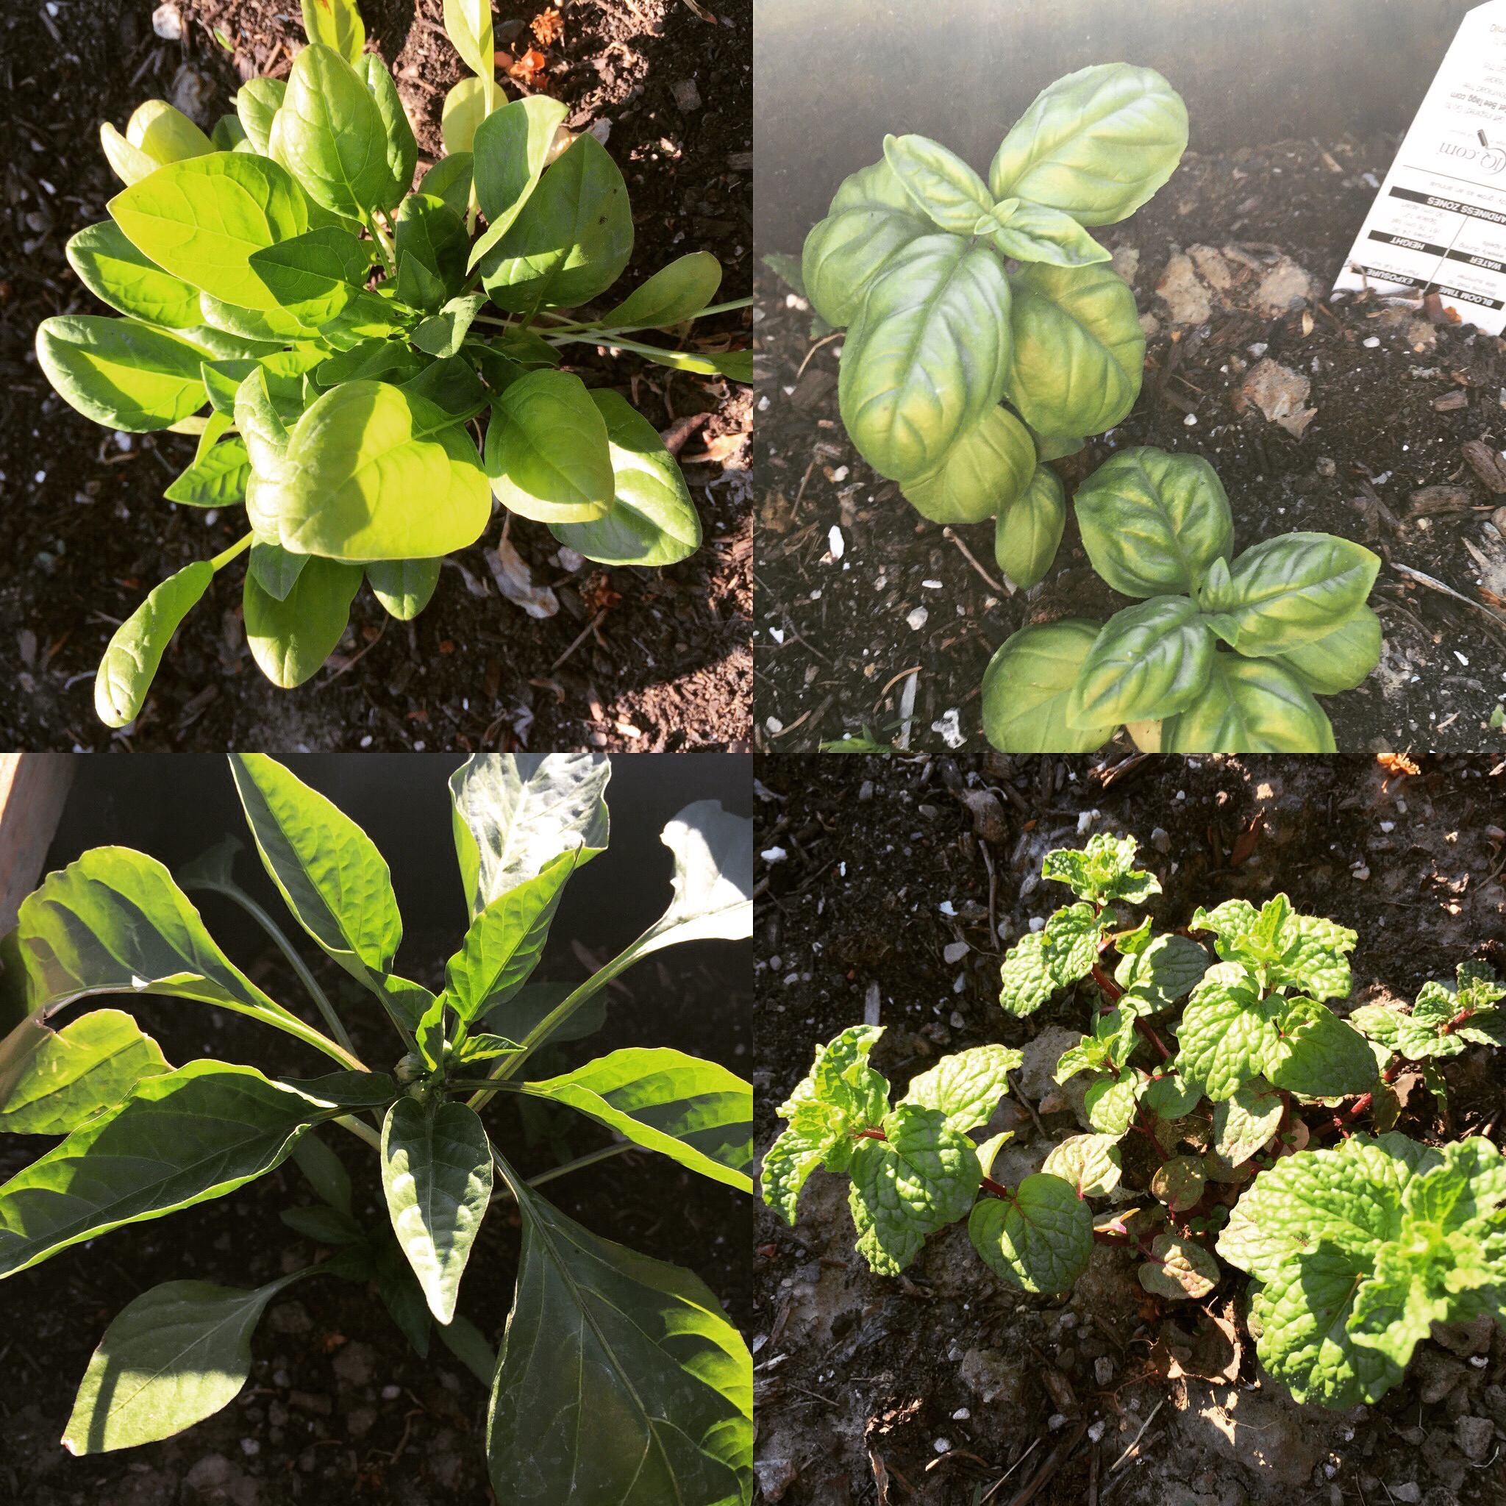

My garden is planted and doing well! I’ve increased the size for this year so that I could plant more potatoes and herbs. Here’s what I’ve got growing in it this year:

* Potatoes
* Tomatoes
* Green peppers
* Onion
* Zucchini
* Beans
* Beets
* Strawberries
* Raspberries
* lavender
* Squash
* Cucumbers
* Green leaf lettuce
* Spinach
* Basil
* Garlic
* Cauliflower
* Cabbage
* carrots

WHAT’S NEW!

* There’s a new E-GUIDE available on the website
* I will be presenting to a wonderful group at the Midland Rec Centre on June 21st
* I will be attending a Corporate Wellness Fair on June 22nd
* I will be at the Wye Nursery for an event on the 26th

MAKE SURE YOU ARE HYDRATED!!

WE SHOULD BE AIMING FOR EIGHT 8oz GLASSES

OF GOOD QUALITY DRINKING WATER PER DAY!

INDIVIDUAL NEEDS DO VARY SLIGHTLY AND ARE DEPENDANT ON OUR AGE, ACTIVITY LEVEL, SIZE, DIET AND THE TEMPERATURE OUTSIDE. READ MORE OVER ON THE WEBSITE BLOG

**WHAT’S IN SEASON**

**JUNE, JULY AND AUGUST**

**APPLES, CHERRIES, RHUBARB, STRAWBERRIES, ASPARAGUS, BEANS, BOK CHOY, BROCCOLI, CABBAGE, CAULIFLOWER, CUCUMBER, LETTUCE, MUSHROOMS, ONIONS, PEAS, PEPPERS, POTATOES, RADICCHIO, RADISHES, RAPINI, RUTABAGA, SPINACH, SUMMER SQUASH, SWEET POTATOES, TOMATOES AND ZUCCHININ**

**\*not all will be available all three months . Pop by foodland.ca for a great guide.**

BALANCED WITH JENNY

www.balancedwithjenny.com